**Adding items to cart.**

Step 1: Navigate to swag labs site using the URL - <https://www.saucedemo.com/>

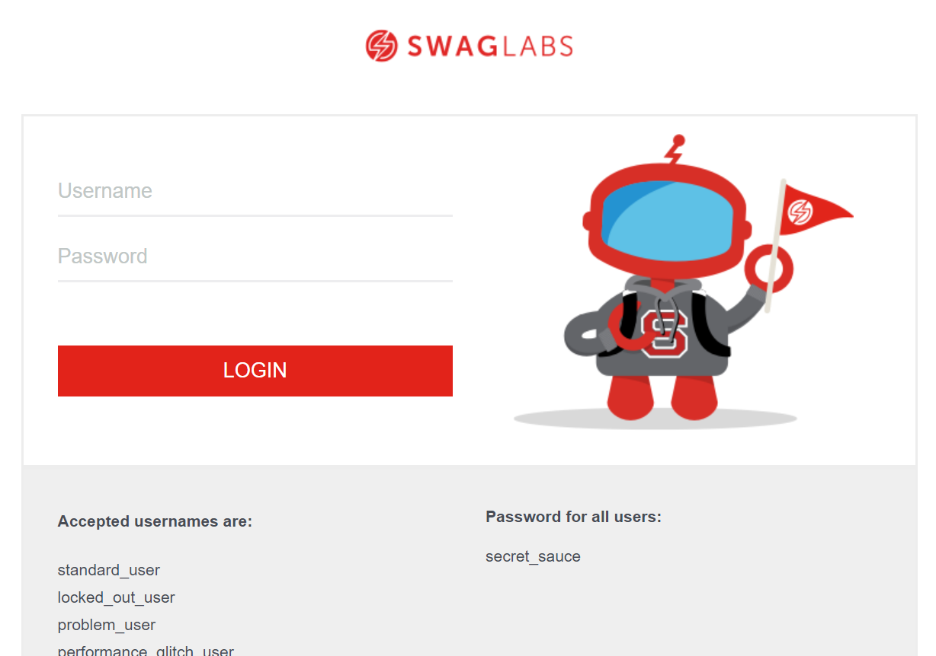

Step 2: Provide valid username and password and click login button. Given: Username= standard_user

Password= secret_sauce

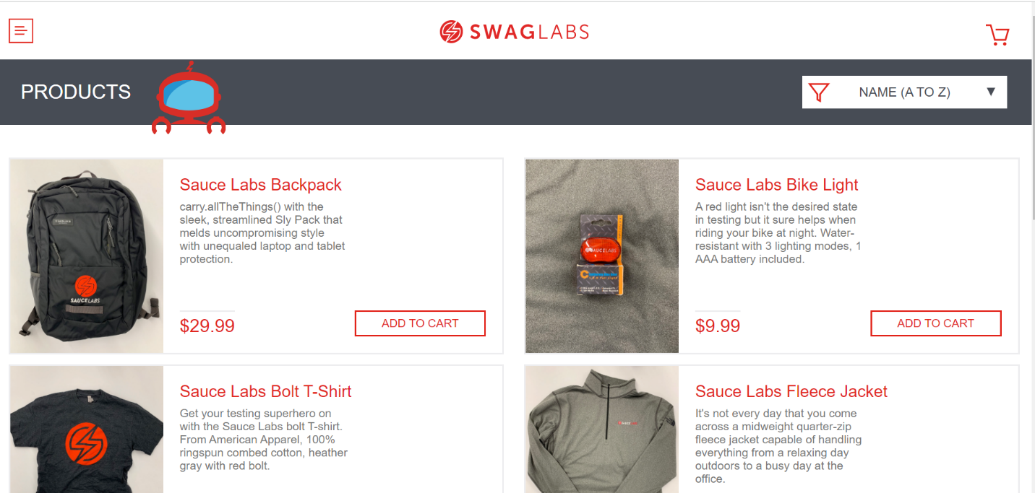

Step 3: By clicking ADD TO CART items should be added to cart.

